BSc (Hons) Computing Course 2025/26
Level 6 Production Project
Name: Anjali Sapkota | Student I.D.: 77466874
Course: BSc (Hons) Computing | Supervisor’s Name: Hari Prashad Joshi
Final Project Individual Aim & Objectives
Title of my Project:
DetectDerm: AI-Powered Skin Disease Identifier for Nepali Users
Aim of my Project:
Goal Project Description “DetectDerm”: Mobile application for detecting, diagnosing and treating 3-5 common skin diseases, advising in local Nepali. This project will create an offline, mobile-application called DetectDerm that is accessible to residents of urban and rural Nepal. The tool will utilize a pre-trained CNN model on publicly available image datasets. This application will not only be able to detect and identify common skin diseases but also provide patients with treatment or consultation advice in Nepali.
Objectives of my Project:
- Detects and classifies 3–5 common skin diseases from images using an AI model (CNN with Transfer Learning).
- Provides Nepali-language recommendations for care or consultation for each detected condition.
- Builds a mobile-friendly, offline-first prototype for accessibility in rural and urban Nepal.
- Measures accuracy, loss, and confusion matrix to evaluate model performance.
- Applies image preprocessing and data augmentation to improve model predictions.
- Collects user feedback from 2–3 users to refine the interface and usability.
- Prepares documentation, flow diagrams, screenshots, and final report for project presentation and evaluation.

Specification of my Product:
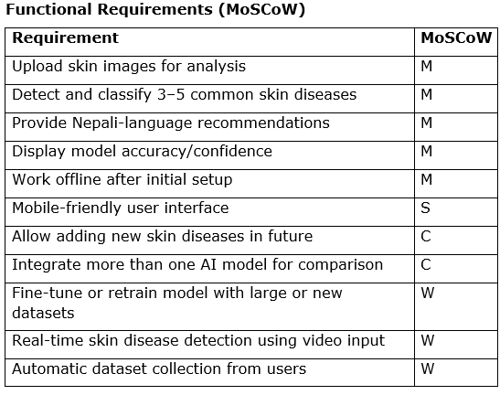
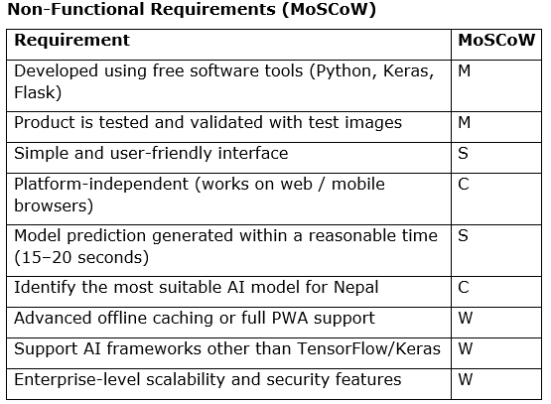
Research:
The skin condition research based on images is important in the healthcare sector. By processing the variety of skin images, a deep learning model known as convolutional neural network (CNN) can learn by pattern Recognition and find an overview of common skin lesions that are identified in skin lesions (Rajakumar, 2024). Models trained in general purpose datasets such as VGG16, VGG19 and Mobile net are often applied in Skin image- classification and object-recognition tasks through transfer learning methods that assist them to achieve significant improvement even on small skin image dataset (Ahmmed et al., 2025).
Developers utilize technologies like the TensorFlow library and Object Detection API to assist in object-detection, -object recognition, object-training and deployment of object-recognition models for mobile devices, since it exploits features learned from already object detection models. Studies show accuracy greater than 90% in detecting Psoriasis, Melanoma and Actinic Keratosis among all the categories (Diagnostics, 2025). Despite certain challenges including uneven dataset, skin type diversity etc., the established methodologies in this research will serve as a baseline for a successful offline and mobile-supported application to provide advice in Nepali language in both urban and rural settings of the region.
Evaluation:
All the aims of DetectDerm project will be checked whether all they are satisfied or not. By checking accuracy, the image in test set which were not used in training: There are 3–5 common skin diseases namely Melanocytic Nevus, melanoma and benign Keratosis will be used. The model will be checked using accuracy, loss and the confusion matrix which will tell the performance. Image of various skin types, various colors, lightning and image quality also tested. Though the image of dark skin(black) may have slight less accuracy, which can be improvised later. We expect the outcome as correct name of disease and a suggestion written in Nepali language. Ease of use, mobile responsiveness, offline functionality will be examined via feedback from 2–3 users.
Project Planning & Methodology
Project Planning:
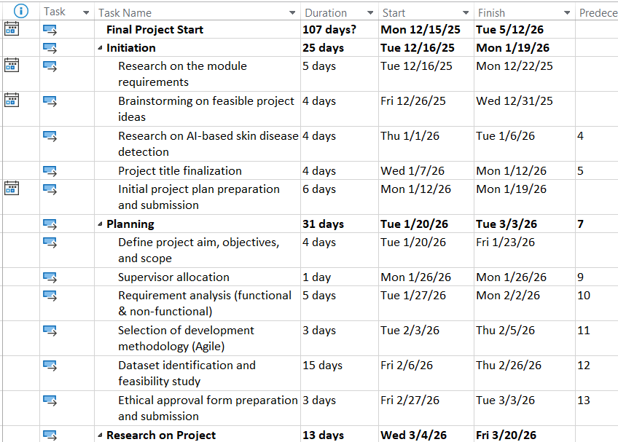
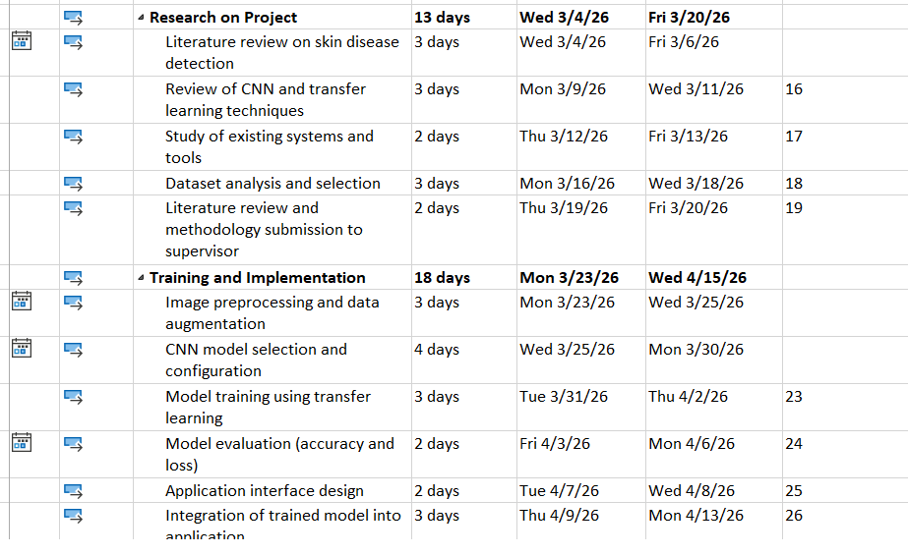
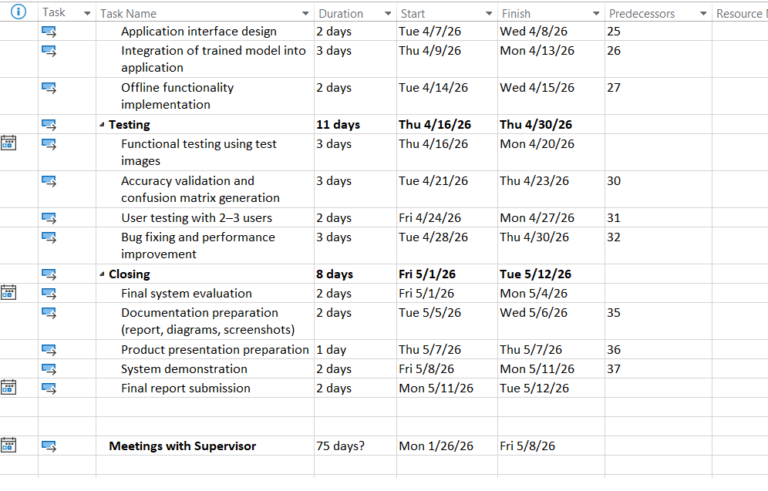
Figure: Task sheet of my project
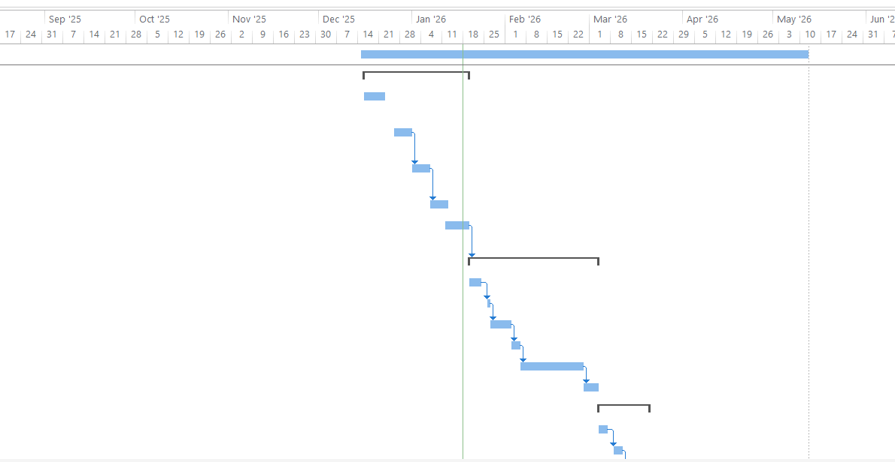
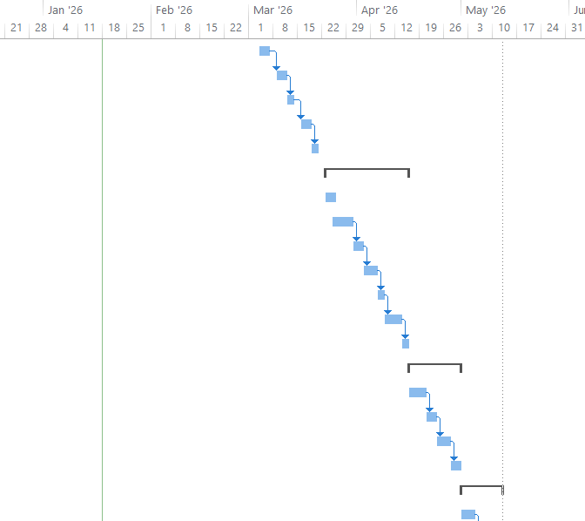
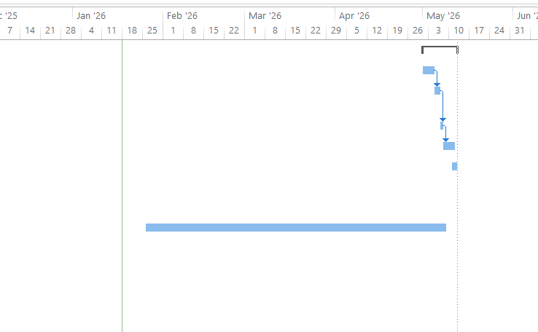
Figure of Gantt chart
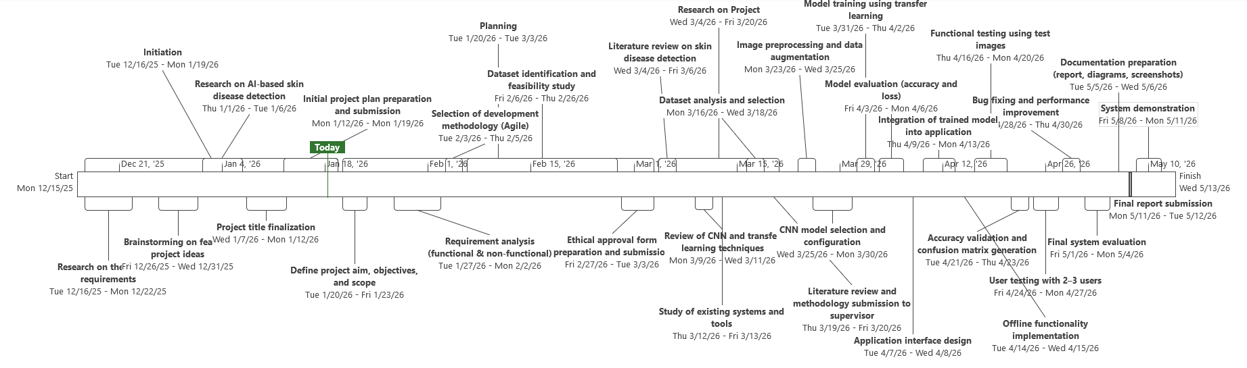
Figure of Timeline
Methodology:
The choice to follow the Agile Methodology is made for the 12 weeks time span which requires both flexible and incremental approach to get the most out of it. The Agile methodology will cater to development through iterations. In short iterations, image acquisition of skin images, development and training of CNN models, testing, reporting of findings and the construction of the mobile interface would be worked upon and each iteration will yield progress. It also accommodates feedback from Nepali user in rapid succession.
Approaches such as Waterfall and RAD will not be followed as Waterfall offers rigidity where changes may not be performed during the training process of the models, and RAD offers no sprints for methodical and structured tests. Furthermore, as seen from the literature, studies (Rajakumar, 2024; Ahmmed et al., 2025) which focus on iterative training has increased the accuracy of CNN models whereas (Fujisawa et al., 2021) underlines the importance to test in the environment as and when needed.
On a similar note, the studies from (Diagnostics, 2025; Duhok Polytechnic University & A. M., 2024) indicates that flexible and incremental approaches are useful for AI based applications which further support the use of Agile for DetectDerm.
Resources
The hardware and software I require to complete my Project successfully:
List of Hardware
- Laptop
- Mobile
List of Software
- Python 3.x
- TensorFlow / Keras
- OpenCV
- NumPy, Pandas, Matplotlib
- Flutter or React Native
- Flask
- Jupyter Notebook or VS Code
- Chrome browser
- Git / GitHub
- Documentation, flow diagrams, screenshots
Human Resource
I am working on my Project with the following people
Name: Anjali Sapkota | Role:  Module Leader: Rohit Raj Pandey  Supervisor: Hari Prashad Joshi
Initial Bibliography
Ahmmed, F., Raihan, M.Z., Nahar, K., Asadujjaman, D.M. & Rahman, M.M., 2025. Skin Disease Detection and Classification of Actinic Keratosis and Psoriasis Utilizing Deep Transfer Learning. arXiv, January. Available at: https://arxiv.org/abs/2501.13713 .
Diagnostics, 2025. Skin Lesion Classification and Detection Using Machine Learning Techniques: A Systematic Review. Diagnostics. Available at: https://www.mdpi.com/2075-4418/13/19/3147 .
Duhok Polytechnic University & A.M., 2024. Skin Disease Recognition Based on Deep Learning Algorithms: A Review. The Indonesian Journal of Computer Science (IJCS), 13(3). Available at: https://ijcs.net/ijcs/index.php/ijcs/article/view/3991 .
Fujisawa, Y., et al., 2021. A Deep Learning Based Framework for Diagnosing Multiple Skin Diseases in a Clinical Environment. Frontiers in Medicine. Available at: https://www.frontiersin.org/journals/medicine/articles/10.3389/fmed.2021.626369/full .
Rajakumar, A., Priya, D. & Muthulakshmi, R., 2024. Skin Disease Classification and Detection Using Deep Learning. Frontiers in Health Informatics, 13(3). Available at: https://pubmed.ncbi.nlm.nih.gov/36655135 .

ID | Risk | Risk Description | Likelihood | Impact | Severity | Owner | Mitigation | Status
1 | Dataset issue | Enough good quality skin images may not be available | Medium | High | High | Anjali | Use different public datasets and apply data augmentation | Resolved
2 | Low model accuracy | The model may not give accurate results | Medium | High | High | Anjali | Use transfer learning and test with different settings | Resolved
3 | Overfitting | Model may work well only on training images | Medium | Medium | Medium | Anjali | Use validation data and data augmentation | Resolved
4 | Hardware limitation | Laptop may be slow during training | Medium | Medium | Medium | Anjali | Use lightweight models and reduce image size | Resolved
5 | Time shortage | Tasks may take more time than planned | Low | High | Medium | Anjali | Follow weekly plan and meet supervisor regularly | Resolved
6 | Offline feature problem | Offline mode may not work properly | Low | Medium | Low | Anjali | Keep offline features simple and test early | Resolved
7 | UI difficulty | Users may find the app hard to use | Low | Medium | Low | Anjali | Take feedback from 2–3 users and improve design | Resolved
8 | Ethical approval delay | Ethical approval process may be slow | Low | Medium | Low | Anjali | Submit ethics form early | Resolved
9 | Software bugs | Errors may appear during development | Medium | Medium | Medium | Anjali | Test the  system  during  development and fix bugs | Resolved
10 | Data privacy concern | Users may worry about image safety | Low | High | Medium | Anjali | Process images locally and do not store them | Resolved
11 | Laptop failure | Laptop may stop working during the project | Low | High | Medium | Anjali | Backup files on GitHub/USB and use lab if needed | Resolved
12 | Insufficient research | Not enough suitable research papers may be found | Medium | Medium | Medium | Anjali | Use Google Scholar and discuss with supervisor | Resolved

